

**Enterprise-wide Quality Integrated Management System**

**HARDWARE& SOFTWARE PRE-REQUISITE DOCUMENT**

**ENTERPRISE CUSTOMERS OR USER CONCURRENCIES > 25**

**Document Control**

|  |  |
| --- | --- |
| **Version Number** | **Nature of Change** |
| 6.0 | Released August 17,2017 |
|  |  |
|  |  |

Table of contents

1.0 System Requirements 3

1.1 Deployment Landscape 3

2.0 Production Instance Deployment Model 4

2.1 High-level Data Flow Chart 6

6

2.2 Hardware & Software Requirements - Production Instance 7

2.3 Database server Requirements 8

2.4 NCache Server Requirements 9

3.0 Non-Production Instances Deployment Model 10

3.1 Hardware & Software Requirements for Non- Production instances 10

3.2 Database server Requirements 12

4.0 Client Machine Requirements 14

* 1. System Requirements

EwQIMS functions on the TCP/IP protocol suite. As such, the performance of EwQIMS is primarily dependent on hardware and network performance. Further, this performance is also linked to other attributes like number of users simultaneously accessing the server, volume of data transaction, and other applications sharing the same hardware and network resources with EwQIMS.

We recommend a LAN – WAN network for implementing this solution globally, using intra-office connectivity with IP based VPN and individual remote or traveling users through the web. (See schematic below). This recommendation can be re-worked based on the current infra-structure of the Customer.

* + 1. Deployment Landscape

EwQIMS deployment landscape would be categorized into

|  |  |  |
| --- | --- | --- |
| S.No | Instances | Purpose |
| 1 | Development Instance  **D** | This instance would be used by Omnex Developers to develop, troubleshoot, debug, deploy custom code and also test the Customization before it’s released to Customer for UAT. This Instance is only applicable for Customization or Integration with Customer existing Software platforms. This is a Non-Production instance. |
| 2 | Staging Instance  **S** | This instance would be used by Omnex Implementation/ Product Development team and Customer Core team to review Service packs/Hot fixes before releasing to Training & Production Instance. This is **highly recommended** for Enterprise Customers/with Users spanning in different geographies. This is a Non-Production instance. |
| 3 | Training Instance  **T** | This instance would be used by Omnex & Customers to train the User groups on the EwQIMS Software through the phases of Implementation. This is a Non-Production instance. |
| 4 | Production Instance  **P** | This instance is for CUSTOMER Production/Live data for all phases. |

NOTES:

* All of our deployments support Dedicated or Virtual Environments.
* Support will be limited if the agreed Hardware & Software pre-requisites are NOT met.
  1. Production Instance Deployment Model

Production Instance Deployment model provides Hardware Specification, Software pre-requisites, Details of deployment for each Instance, number of databases including Reporting services. Production instance will be resized depending on SOW amendments and clarity on the Data sizing. **For more than 25 Concurrent users, Load balancer with multiple Web server deployment model will be recommended.**

|  |  |  |
| --- | --- | --- |
| Sr. No | Server Name | Number of Servers. |
| 1 | Application/ Web Servers | 2 + |
| 2 | Database Server | 1 |
| 3 | NCache Server | 2+ |
| 4 | Load Balancers (Hardware preferred) | 1 |
| *Table 1: EwQIMS Deployment given above is for Production instance.*  EwQIMS Deployment Architecture: | | |

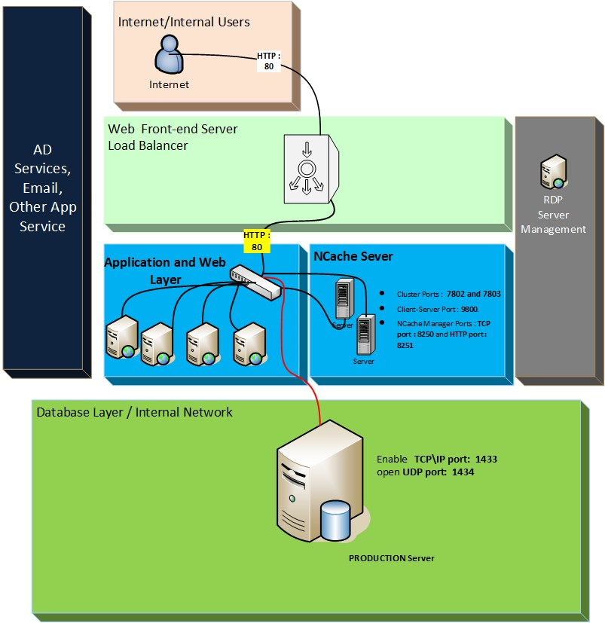

* + 1. High-level Data Flow Chart

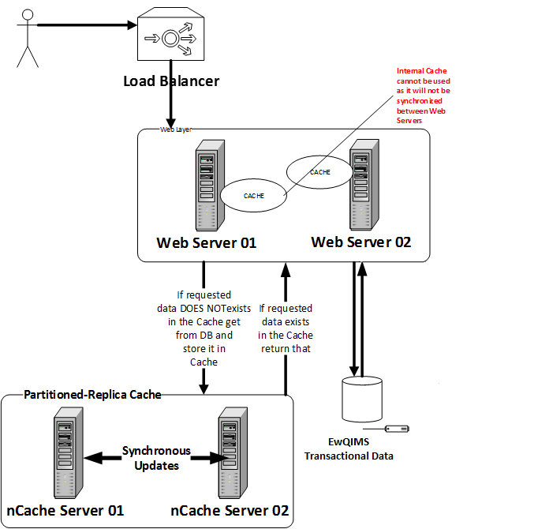

.

NCache server only needed when Aqua Pro is purchased.

* + 1. Hardware & Software Requirements - Production Instance

**Application Server Requirements**

|  |  |
| --- | --- |
| Component | Minimum requirement |
| Processor | Quad-core processor or above (8CPU) |
| RAM | Web Server 64 GB |
| Hard disk | 100GB Maintain as much free Hard disk Space for better performance. |
| Application Server | * Operating System   Windows Server 2012 /2016 *(recommended)* Standard, Enterprise, Data Center 64 Bit with the following software   * + Web Servers and application   + Web Server (IIS) role   + Application Server role   + Microsoft .NET Framework 2.0   + Microsoft .NET Framework version 3.5 SP1   + Microsoft .NET Framework version 4.0   + Microsoft .NET Framework version 4.5   + Adobe SVG View 3.0.3 *   + Silverlight 5.0   + Ajax component (Bundled in the EwQIMS Installation kit)   + Adobe Acrobat Reader 10.0 or above   + Flash Player 10 or above |
| Windows User credentials  ( Local User) | To Configure the Application (COM+) – setup using the Network Service. |
| IIS ApplicationPools | * + .Net Framework Version : v4.0   + Enable 32-Bit Application : True   + Managed Pipeline Mode: Classic   + Process Model Identity : NetworkService |
| OMNEX Application folder Access Right | * + EwQIMS default User : Full Access   + IIS User : Full Access   + NetworkServices : Full Access   + Authenticated Users: Full Access   (All these user has Full Access to the Temp folder) |
| ODBC | 32 Bit ODBC for transaction |
| Firewall port for SQL Server Connection | SQL Server Connectivity from IIS server   * Enable   TCP\IP port  1433 * open UDP port 1434 |

*: will be provided along with the installation kit.

* + 1. Database server Requirements

|  |  |
| --- | --- |
| Component | Minimum requirement |
| Processor | Quad-core processor or above(8CPU) |
| RAM | Server 64GB |
| Hard disk | 500GB  Maintain as much free Hard disk Space for better performance. |
| Operating System | Windows Server 2012 / 2016 Standard, Enterprise, Data Center 64 Bit or higher |
| Database server | Microsoft SQL Server 2012 / 2014 / 2016 with   * Management Studio * Mixed Mode Authentication * Full-Text Search * SQL Server Business Intelligence Development Studio * Reporting Services (SSRS) |
| Credential | DBA User with Database Creation right ( During the installation , this credential is used to create new EwQIMS Database ) |
| Dedicated SQL Account for EwQIMS | SQL User with EwQIMS Database Owner ( Application layer is using this account for transaction) |
| Firewall port for SQL Server Connection | SQL Server Connectivity from IIS server   * Enable   TCP\IP port  1433 * open UDP port 1434 |
| SQL Surface configuration | Enable   * Remote access * TCP/IP * NamedPipes |

* + 1. NCache Server Requirements

|  |  |
| --- | --- |
| Component | Minimum requirement |
| Processor | PE 2950's Dual Core Xeon Processor 5160 4MB  Cache, 3.00GHz, 1333MHz FSB, PE 1950 |
| RAM | 4 to 8Gb RAM (8 GB recommend) |
| Operating System | Windows Server 2008/2012 Standard, Enterprise, Data Center 64 Bit or higher |
| Additional Software Requirements | Ncache Software. Ncache Licenses are Processor (CPU) based licenses |
| Number of Servers | 2 |
| HDD | Minimum of 200 GB, recommended 400GB or above. |

NCache is an extremely fast and scalable in-memory distributed cache that caches application data, reduces expensive database trips, stores ASP.NET Session State and Java JSP Sessions in web farms

NCache is an extremely fast in-memory cache. It is much faster than going to the database to read data. NCache provides sub-millisecond response times to its client

Ref : http://www.alachisoft.com/ncache/core-capabilities.html

Partition-Replica Cache (with replication):

<http://www.alachisoft.com/ncache/caching-topology.html>

Reference data: Good. 30000 reads/sec per server. Grow linearly by adding servers.

Transactional data: Good. 20000 writes/sec per server. Grow linearly by adding servers.

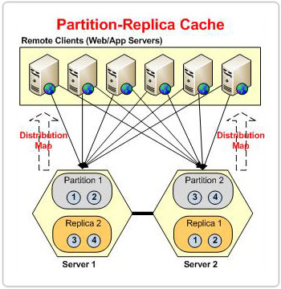

* 1. Non-Production Instances Deployment Model

Training, Staging & Development Deployment can be with individual Application Server for each instance and one Database Server have all the 3 instance database. For example, EwQIMS Training Application will be installed on the Application layer and pointed to a Training Database in a Database Server. NOTE this Database Server SHALL NOT have the Production database.

Development (Application Server)

Database

Server

Staging

(Application Server)

Training

(Application Server)

* + 1. Hardware & Software Requirements for Non- Production instances

**Application Server Requirements for each Deployment mentioned above**

|  |  |
| --- | --- |
| Component | Minimum requirement |
| Processor | Quad-core processor or above (8CPU) |
| RAM | Web Server 16 GB recommended, (minimum of 8 GB RAM) |
| Hard disk | 100GB  Maintain as much free Hard disk Space for better performance. |
| Application Server | Operating System  Windows Server 2012 /2016 (Recommended) Standard, Enterprise, Data Center 64 Bit with the following software   * Web Servers and application * Web Server (IIS) role * Application Server role * Microsoft .NET Framework 2.0 * Microsoft .NET Framework version 3.5 SP1 * Microsoft .NET Framework version 4.0 * Microsoft .NET Framework version 4.5 * Adobe SVG View 3.0.3 * Silverlight 5.0 * Ajax component (Bundled in the EwQIMS Installation kit) * Adobe Acrobat Reader 10.0 or above * Flash Player 10 or above |
| Windows User credentials  ( Local User) | To Configure the Application (COM+) – setup using the Network Service. |
| IIS ApplicationPools | * .Net Framework Version : v4.0 * Enable 32-Bit Application : True * Managed Pipeline Mode: Classic * Process Model Identity : NetworkService |
| OMNEX Application folder Access Right | * EwQIMS default User : Full Access * IIS User : Full Access * NetworkServices : Full Access * Authenticated Users: Full Access   (All these user has Full Access to the Temp folder) |
| ODBC | 32 Bit ODBC for transaction |
| Firewall port for SQL Server Connection | SQL Server Connectivity from IIS server   * Enable   TCP\IP port  1433 * open UDP port 1434 |

* + 1. Database server Requirements

|  |  |
| --- | --- |
| Component | Minimum requirement |
| Processor | Quad-core processor or above(8CPU) |
| RAM | Server 16 GB (32 recommended) |
| Hard disk | 500GB  Maintain as much free Hard disk Space for better performance. |
| Operating System | Windows Server 2012/2016 Standard, Enterprise, Data Center 64 Bit or higher |
| Database server | Microsoft SQL Server 2008 / 2012 / 2014 with   * Management Studio * Mixed Mode Authentication * Full-Text Search * SQL Server Business Intelligence Development Studio * Reporting Services (SSRS) |
| Credential | DBA User with Database Creation right ( During the installation , this credential is used to create new EwQIMS Database ) |
| Dedicated SQL Account for EwQIMS | SQL User with EwQIMS Database Owner ( Application layer is using this account for transaction) |
| Firewall port for SQL Server Connection | SQL Server Connectivity from IIS server   * Enable   TCP\IP port  1433 * open UDP port 1434 |
| SQL Surface configuration | Enable   * Remote access * TCP/IP * NamedPipes |

An alternate to the Non-Production Deployment models are that **each instance** have its Application Server and Database Server on a single box/single Virtual Machine.

|  |  |
| --- | --- |
| Component | Minimum requirement |
| Processor | Quad-core processor or above (8CPU) |
| RAM | Web Server 16 GB recommended |
| Hard disk | 500GB  Maintain as much free Hard disk Space for better performance. |
| Application Server | Operating System  Windows Server 2012 /2016 (Recommended) Standard, Enterprise, Data Center 64 Bit with the following software   * Web Servers and application * Web Server (IIS) role * Application Server role * Microsoft .NET Framework 2.0 * Microsoft .NET Framework version 3.5 SP1 * Microsoft .NET Framework version 4.0 * Microsoft .NET Framework version 4.5 * Adobe SVG View 3.0.3 * Silverlight 5.0 * Ajax component (Bundled in the EwQIMS Installation kit) * Adobe Acrobat Reader 10.0 or above * Flash Player 10 or above |
| Windows User credentials  ( Local User) | To Configure the Application (COM+) – setup using the Network Service. |
| IIS ApplicationPools | * .Net Framework Version : v4.0 * Enable 32-Bit Application : True * Managed Pipeline Mode: Classic * Process Model Identity : NetworkService |
| OMNEX Application folder Access Right | * EwQIMS default User : Full Access * IIS User : Full Access * NetworkServices : Full Access * Authenticated Users: Full Access   (All these user has Full Access to the Temp folder) |
| ODBC | 32 Bit ODBC for transaction |
| Firewall port for SQL Server Connection | SQL Server Connectivity from IIS server   * Enable   TCP\IP port  1433 * open UDP port 1434 |
| Database server | Microsoft SQL Server 2012 / 2014 / 2016 with   * Management Studio * Mixed Mode Authentication * Full-Text Search * SQL Server Business Intelligence Development Studio * Reporting Services (SSRS) |
| Credential | DBA User with Database Creation right ( During the installation , this credential is used to create new EwQIMS Database ) |
| Dedicated SQL Account for EwQIMS | SQL User with EwQIMS Database Owner ( Application layer is using this account for transaction) |
| Firewall port for SQL Server Connection | SQL Server Connectivity from IIS server   * Enable   TCP\IP port  1433 * open UDP port 1434 |
| SQL Surface configuration | Enable   * Remote access * TCP/IP   NamedPipes |

* 1. Client Machine Requirements

|  |  |
| --- | --- |
| Component | Minimum requirement |
| Processor | Dual cores 2.10 Ghz |
| RAM | 4 GB or 8 GB (8 GB recommended) |
| Client Software Requirement | * Microsoft Internet Explorer (MS IE) 11 or above * Adobe SVG View 3.0.3 * Silverlight 5. * Flash Player 10 or higher * Adobe Acrobat Reader 10.0 or above |

**END.**